Revision Date | Version | Comment
01/08/2009 | 1.0 | Original Policy
23/03/2023 | 1.1 | Review
Policy approved by: |  |  | Signature | Date
Policy Owner:
Managing Director: |  | Steve Hine
Keywords: |  | Email signature

The following steps must be followed to insert the Email Signature and Disclaimer:

- In Microsoft outlook select “Tools” from the top bar

- From the “Tools” dropdown menu select the “Options” button and activate the “Mail Format” tab.

- Activate the “Signature” option:

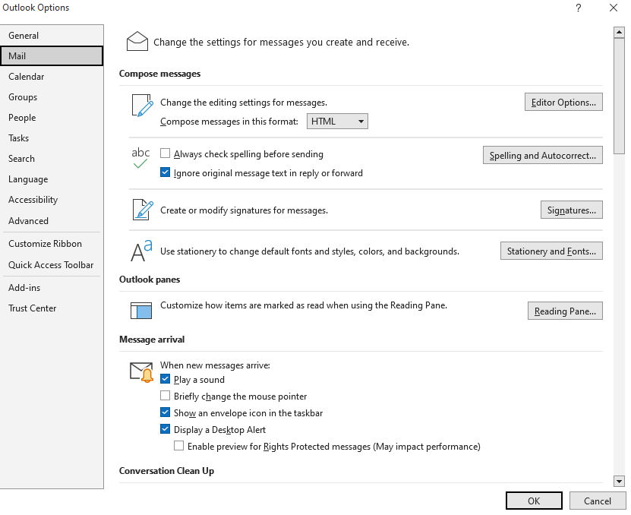

- Press the “New” button and give your signature a name e.g.” Giscoe - signature”

- Copy and past the Signature below from the file server into the space provided for the new signature.

- Save the signature

- The signature can be set as default meaning that each time you answer someone the signature will be added at the bottom of the Email communication.
 | Employee Name and Surname  Employee Title  Office Physical Address |  | Tel:  Mobile: | + 27 (0)Office Tel  + 27 (0)Your Mobile number if need be
http://www.giscoe.com
your work e-mail address: e.g. jsmit@giscoe.com

DISCLAIMER: The information in this message is confidential and legally privileged solely to the intended addressee. The opinions or statements expressed herein are my own and should not be taken as the official opinion or endorsement of Giscoe (Pty) Ltd

